Acces Specifers:

**Acess specifiers**

Access specifiers (access modifiers) are keywords used to set the access level for classes, variables(fields), methods, and constructors**.**

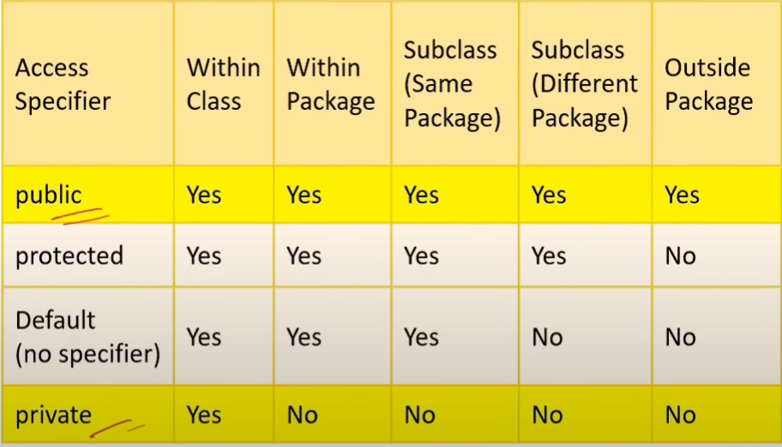

**package Acessspecfiers;**

**import Acessspecfiers1.Age;**

**public class Student {**

**public String name="charan";**

**String city="hyd";**

**public static void main(String[] args) {**

**// TODO Auto-generated method stub**

**Student s=new Student();**

**System.*out*.println(s.name);**

**System.*out*.println(s.city);**

**}**

**}**

**package Acessspecfiers;**

**public class Sciencestudent {**

**public static void main(String[] args) {**

**Student s=new Student();**

**System.*out*.println(s.name);**

**System.*out*.println(s.city);**

**// TODO Auto-generated method stub**

**}**

**}**

**package Acessspecfiers;**

**public class Ageofthestudent {**

**int age=10;**

**}**